Stubby Leas Nursing Home

Statement of Purpose
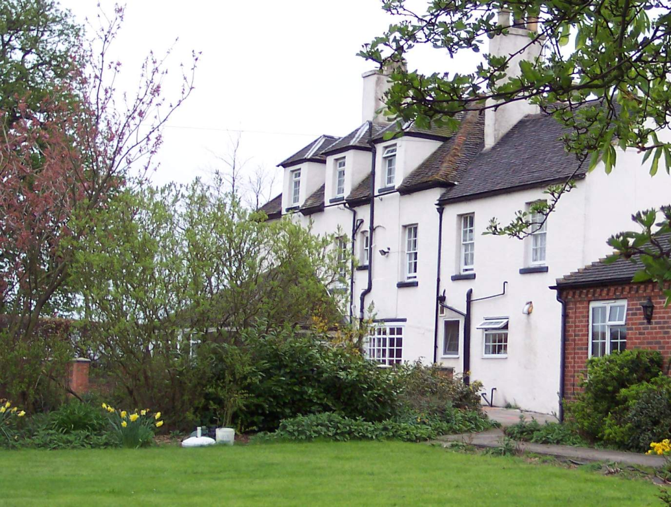


Fisherwick Road
Whittington
Lichfield
Staffordshire WS13 8PT

Tel: 01827 383 496/762
Fax: 01827 383 086
Email: admin@stubbyleasnursinghome.com

Registered Manager: Simone Robinson

Nominated Individual: Jagruti Patel

CONTENTS

Introduction and brief description Page 3

Aims of the Home and catering Page 4

Admission criteria, quality control, safety and provider details Page 5-6

1st Care and the Home’s staffing structure Page 5-6

Reviews, rights and support Page 7-8

Facilities, social care and pets Page 9-10

Complaints, property, gifts and the CQC Page 10-12

Further information, advocacy and the Home’s philosophy of care Page 13

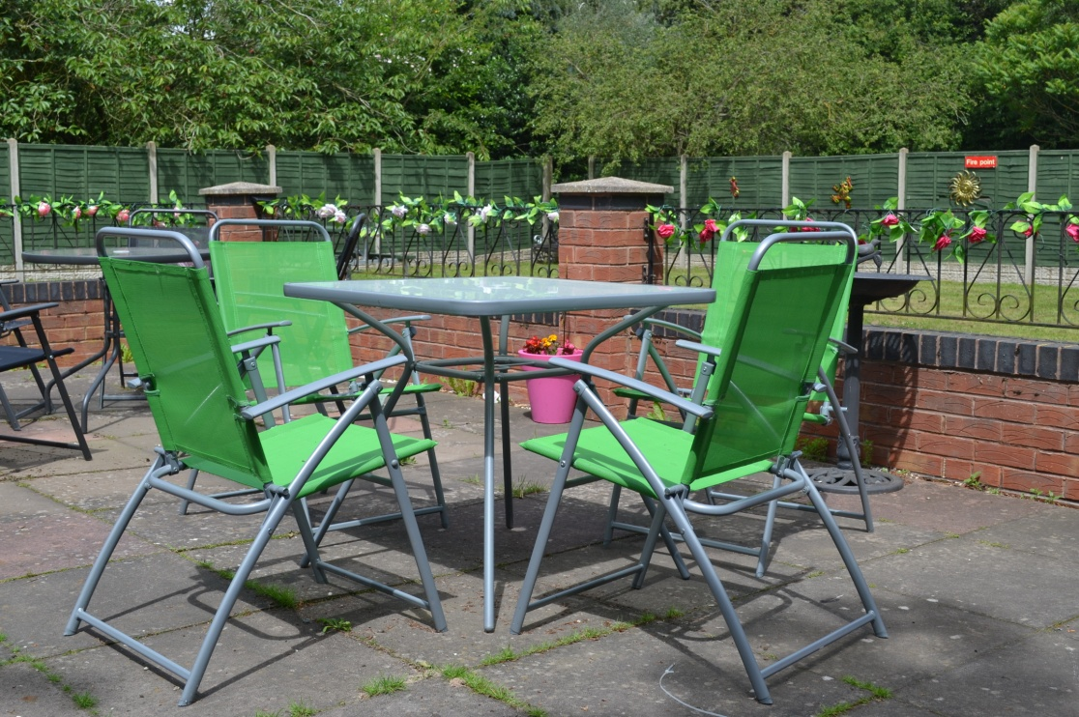
A peaceful setting in the garden

Welcome to

Stubby Leas Nursing Home

Introduction

We fully appreciate that the prospect of needing to consider a move into a Care Home for either yourself or a member of your family is a huge decision. Indeed, we accept that this may be one of the most difficult and complex processes you may ever need to encounter.

The Health and Social Care Act 2008 (Regulated Activities) Regulations 2014 requires each Care Home to compile a written guide about the Care Home which is referred to in the Regulations as the “Statement of Purpose”.

Overall aim of this Guide

This guide aims to include information a person may need to help:

People make decisions about the suitability of the Care Home and whether it may meet their future needs prior to moving into the Home

Make valued judgements as to whether the Care Home is continuing to provide the level of services that were specified as part of the Terms and Conditions of Residence

Ensure that the views of people using the service are taken into consideration, and that people can influence the day-to-day operation of the Home.

This guide is designed to provide you with important information about the running of Stubby Leas, and your rights as a person using, and living at the Home. If you would like any assistance with understanding this guide then please ask a member of our senior staff who will be pleased to help you.

A brief description of Stubby Leas Nursing Home

The home is located 4 miles from Lichfield on the edge of Fisherwick Village in the heart of the beautiful Staffordshire countryside and can be reached by road through Whittington village or by bus from Lichfield to Elford with a short walk to the home.

Stubby Leas’ was originally a large house built over 200 years ago and has been extended to provide a comfortable nursing and residential home for people who are in need of twenty-four hour care.
Stubby Leas is registered with the Care Quality Commission (the “CQC”) to provide accommodation for up to 48 people who require nursing or personal care. The Home is also registered to provide diagnostic and screening procedures, and can undertake the treatment of disease, disorder or injury.

What accommodation will I expect to find?

All rooms possess a nurse call alarm system, reading lights, electrical sockets and central heating.

All furnishings are fire retardant to BSI standard and the Home operates a fully-functional smoke and fire detection system for safety purposes. Accommodation is provided on three floors and two fully maintained mechanical passenger lifts access all floors.

Each person’s room includes bedding appropriate to the needs of the individual, a wardrobe, a bedside table and chest of drawers. People are welcome to bring their own furniture and furnishings, and the staff team will encourage and support people to personalise their rooms as much as possible.

Stubby Leas has a lounge area located in the “main wing” on the right-hand side of the building on entering, and a second lounge in “cottage wing” located on the left-hand side of the building on entering. Stubby Leas has a dining area and a tea rooms/family area with a conservatory attached is positioned centrally in the Home. Each dining and lounge area has views of and access onto the Home’s grounds.

We do suggest and encourage people to make choices about décor and furnishings as far as is practical. The Home has a central laundry located on the ground floor and sluicing facilities.

Aim of the home

We aim to provide care, support and treatment which maximises people’s quality of life, lifestyle choices and experiences, preferences, independence and liberty.

We provide specialist nursing and personal care for older-age adults with memory loss problems, physical healthcare conditions and life-limiting illnesses.

Arrangements for transportation
Where people require transport for personal use or for appointments a charge will apply. This charge will cover the cost of transport along with any staff support required.

What are the facilities and services


What meals can I expect? All meals will be carefully prepared by our catering team in consultation with people using the service. We will attempt to ensure our meals are as appetising, interesting and varied as possible. People will be offered choices each day and special dietary requirements will be catered for. Stubby Leas operates a four-week menu which is revised on a seasonal basis.

Each person is offered up-to three cooked meals a day (breakfast (usually served between 8 and 10:30am), dinner (served between 12:30 and 2pm) and supper (usually served between 5pm and 6pm). Hot and cold drinks and snacks are available throughout the day and night-time periods – with evening drinks and snacks provided after 8pm.

Should people wish to bring in meals or wish to keep food within their rooms we do welcome this however, food safety arrangements must be discussed and agreed with the Manager to ensure the health and safety of people using the service is protected and promoted at all times.

All meals, snacks, supplements and drinks are provided within the fees for service. Special diets are catered for and advice of dietetic services is sought where necessary. Limited quantities of alcohol are offered at special occasions.

Nursing Care Provision
A nurse with up-to-date registration with the NMC (the “Nursing & Midwifery Council”) is on waking duty throughout the entire 24-hour period, and directs and oversees the care provided.

Admission criteria
It is not operational policy to accept unplanned (or “emergency”) admissions to the Home. All enquiries for admission are coordinated by the Manager – who will undertake a pre-admission assessment prior to any person being admitted to Stubby Leas. The purpose of the pre-admission assessment is to assess a person’s care needs and establish whether the Home can provide the level of care and support necessary to meet the person’s needs.

Quality control
The Home carries out regular audits of all aspects of care and service delivery including:

- Care audits
- Cleanliness and infection prevention and control (IP&C) audits
- Meal and mealtime audits
- Medication management audits
- Environmental audits
- Accident and incident audits
- Health and Safety audits

1st Care promotes 360º feedback and, as such, 1st Care’s Nominated Individual or an appointed Auditor undertakes unannounced visits to the Home and audits service provision, delivery and regulatory compliance. Her audit generates an action plan for the Home to follow to promote service delivery. Customer satisfaction surveys are also undertaken – aimed at gaining feedback from people using the service and their relatives about service provision at Stubby Leas.

Fire precautions and emergency procedures in the home
Stubby Leas’ fire detection and prevention systems have been developed with advice and guidance from the local Fire Authority and external fire safety advisors. The Home undertakes regular fire drills, fire alarm tests and ensures all staff receive fire safety training.

On appointment, staff are inducted on other aspects of emergency planning, and these include:

- Fire and Evacuation Procedures
- Emergency Planning
- Accident and Incident Reporting
- Missing Person’s Procedure

Name, address and profile of the Registered Provider and Care Manager

Registered Provider:
1st Care L^{td.}
Address
Head Office
90b Handsworth Wood Road Handsworth Wood
Birmingham B20 2PL
T 0121 554 5024
F 0121 523 6001
Nominated Individual:
Jagruti Patel
Address
Head Office
90b Handsworth Wood Road Handsworth Wood
Birmingham B20 2PL
T 0121 554 5024
F 0121 554 5024
Registered Manager:
Simone Robinson
Address
Stubby Leas Nursing Home
Fisherwick Road
Whittington
Lichfield WS13 8PT
T 01827 383 496/762
F 01827 383 086

Email: Email: Email:
admin@1stcareltd.co.uk jagpatel@1stcareltd.co.uk manager@stubbyleasnursinghome.com

Information regarding 1st Care L^{td}

1st Care Ltd is an experienced quality driven social care operator having established 2001. It manages four homes including Stubby Leas. The other Homes include Acorn Care Home, Birmingham a highly specialist care home for younger adults with a dementia, Orrell Grange Nursing Home in Liverpool and Hawthorne Nursing Home, Nottingham. The owner and Nominated Individual of 1st Care is Mrs. Jagruti Patel – who is also a qualified pharmacist.

Information regarding Simone Robinson
Simone is a registered nurse (RMN), and qualified in 1989. She holds a counselling certificate, a post-registration qualification in teaching and assessing (clinical practice (ENB 998)) and holds a degree in contemporary studies (BA (Hons). Simone commenced employment at Stubby Leas in January 2014 as a staff nurse, became Deputy Manager and was then appointed as Manager in November 2014.

Arrangements for reviewing support plans
Stubby Leas Nursing Home operates a full support planning and review system.

On admission each person is assessed and a series of support plans are formulated. These plans cover all areas of a person’s life and (assessed) support needs – aimed at enhancing each person’s quality of life and wellbeing. A pen picture of each person’s life history - including interests and activities - is created.

People’s care will be reviewed at least monthly however everybody is welcome to ask for a care review at any time. With your agreement, your relative or representative will be invited to your care review. Should you wish to represent yourself we will accommodate your request.

Arrangements for respecting privacy and dignity
All staff are instructed, as part of their induction, to respect people’s privacy and preserve their dignity at all times. Privacy and dignity are issues that are revisited during staff supervision sessions.

The Home’s Staff
Organisational Structure of the Home
Managing Director/Nominated Individual: Mrs. Jagruti Patel

Head Office (Birmingham)

Home Manager: Simone Robinson

Administrator
Deputy Manager
Registered Nurses

Senior Carers
Carers
Catering Team
Domestic Team
Laundry Team
Maintenance

Activity Coordinators

What are my rights as a User to your service?

All people who chose to live at Stubby Leas have:

- The right to be called by the name of your choice
- The right to care for yourself as far as you are able
- The right to take personal responsibility for your own actions and expect all staff to accept that a degree of risk is involved
- The right to personal privacy at all times and a right to lock your own room door
- The right to invite whoever you choose into your room
- The right to receive visitors at any reasonable time
- The right to refuse visitors
- The right to independence
- The right to have your dignity respected and to be treated as an individual
- The right to receive equality of opportunity which is responsive to your race, religion, culture, language, gender, sexuality, disability and age
- The right to live your chosen lifestyle
- The right of access to your own personal records and information relating to decisions made with all staff that affect your life, and to be assisted with this
- The right to have a regular review of your care, copies of your care plans, and prior (7 days) notice if arranged by your carers on your behalf
- The right to take an active part in any decisions about daily living arrangements that affect your life
- The right of access to outside agencies of your choice e.g. doctor, optician, chiropodist etc., and where necessary to be assisted with this
- The right to look after your own medication, if you are assessed to be able to do so
- The right to have up-to-date information about your medication
- The right to be assessed to self-medicate
- The right to control your own finances, if you are assessed to be able do so
- The right to make personal life choices (such as what food you eat and what time you get up and go to bed)
- The right to access a formal complaints procedure and to be represented by another service user, a friend, relative or advocate if necessary
- The right to access an advocate at any reasonable time and the right to visit an advocate in private
- The right to question services provided and be part of a committee to represent you
- The right to participate in voting.


Medical care – registered nurses and care staff: Staff are always on duty to plan and support care, ensuring the highest standards at all times. All nurses - including the Manager - are registered nurses. All our nurses have many years of experience of working in both acute elderly or medical healthcare settings and care home experience. A large proportion of our care staff are qualified to GNVQ level 2 or equivalent in care. All carers are supervised by senior carers and registered nursing staff.

Will I get a say on what happens in the care home? People are actively encouraged and supported in having a direct involvement in support plan decisions, choices and reviews. We encourage and activity support home visits from your own family doctor and people may retain their own doctor if this is practical. District nurses and other members of the primary care team are encouraged to visit people and form part of the review and process of care.

We have visiting GP’s who are able to examine users jointly with a nurse.


Optician and dentist: An optician and dentist visit regularly although you are free to make appointments outside if you prefer.

Physiotherapy: Can be arranged as necessary.

Podiatry (chiropody): A private chiropodist can visit the Home and would be charged separately.

Hairdressing: An independent hairdresser visits each week at an additional charge - although you may wish to go out to a hairdresser or barber. Hairdressing is provided, at an additional charge.

Telephones: The telephone number for the home is 01827 383 496/762 and the fax number is 01827 383 086. Individuals may request a private telephone for their room however the cost of the installation plus ongoing costs must be met by themselves.


Laundry: This is undertaken in the Home as part of the normal fees. The Home expects all personal clothing to be labelled and cannot be held responsible for any loss of items not so marked. Dry cleaning is not included within the normal service provision at Stubby Leas.

Kitchen facilities: These facilities are not accessible to people using the service at Stubby Leas Nursing Home due to Health & Safety, Environmental Health and Food Hygiene Regulations. Service users can avail themselves of drinks and snacks at most times by requesting these from care staff.

Personal toiletries: People living at Stubby Leas Nursing Home – or their nominated representative/s – are responsible for the provision of personal toiletries.

Bedrooms
Bedrooms at Stubby Leas Nursing Home range in size from 10m² (standard bedroom) up to (in excess) of 20m² (deluxe bedroom). Each room is priced individually. For further information on pricing, please feel free to contact the Home’s Manager or Administrator.

Attention is drawn to the Home’s insurance arrangements which place a limit on the value of items insured within the Home. For further details, please see the Home’s Administrator or Manager.

Can I attend religious services?
Stubby Leas Nursing Home takes all reasonable steps to ensure that each person’s wishes, preferences and beliefs are known and understood in relation to the practice of their chosen religion. Where requested, we will observe and ensure confidentiality in respect of religious belief or alternatively, we will take such steps as may be necessary to enable people to attend religious services or to access religious leaders, ministers or priests in private.

Arrangements for social activities, hobbies & leisure interests
We understand the importance of structured activities for people. Activities can provide a sense of purpose and belonging that many people may find hard to experience. Each person is given the opportunity to participate in structured activities Stubby Leas is able to provide a variety of ways that people can engage in the enjoyment of social activities, hobbies and leisure interests. We have a safe, enclosed garden for individuals to use, and individual wishes regarding involvement in activities are always respected as we recognise the balance between gentle encouragement and respecting an individual’s wish not to participate.

We employ activity coordinators to help and support people to have an active, interesting and stimulating day.

Can I bring a pet to the Home?
1st Care understands how important pets are to people and how the relative sense of loss experienced when moving into a care service can be upsetting. Likewise, the emotional distress of having to give up on a pet companion is also understood. The Home does not discriminate against pets but, also acknowledges that, should an individual want to bring in their own pet on admission to the Home, careful planning and negotiation would need to take place to ensure the health, safety and wellbeing of all parties is respected and met. For further information please ask to see the Manager.

Do I get a say in the running of the home?
Our Home is committed to ensuring that people are fully consulted about matters which are significant to the running of the Home or about matters which might affect their well being or quality of life.

Our Home regards this honest feedback, whether positive or constructive opinion, as useful in developing our services further. For this reason we undertake customer feedback questionnaires for residents and relatives to complete and return. Feedback is then analysed and an action plan developed and implemented in response to the feedback provided.

Can I maintain contact with my relatives, friends and representatives?

Stubby Leas Nursing Home actively encourages people to maintain all the forms of social contact they enjoyed before moving into our Home. We will assist people to maintain contact if requested.

This is a user’s Home and, subject to individual wishes, visitors are generally welcome at any time.

Normal visiting is encouraged between 8 am and 10 pm. At other times relatives are asked to telephone prior to their intended visit. All visitors are requested to enter their details in the ‘Visitors Book’ and to sign out on departure. Visitors should be made aware that this is to comply with Health & Safety and Fire Regulations.

People can usually receive visitors in their own room or in one of the lounges or, outside meal times, in the dining room. 1st Care has a corporate policy entitled. This helps to ensure that each person using our service is able to enjoy their meals and the mealtime experience without being distracted. As such, appointments are actively discouraged during the Home’s mealtimes.

Visitors wishing to take people from the premises should speak to the nurse on duty first to ensure that any prescribed medication can be provided or supplied, and that the trip out is within the capacity of the person. A comprehensive risk assessment would then need to be undertaken and agreed to ensure the health, safety and wellbeing of the individual.

Relatives and friends are encouraged to attend social events such as the Home’s Christmas Party, Summer Fair, entertainment evenings etc.


Can I make a complaint and will I be listened to?
1st Care welcomes concerns and complaints about services delivered, or suggestions about how to improve the running of the Home. Complaints or concerns about the service provided within any Home will be treated seriously. We encourage a grassroots approach to dealing with suggestions, comments and complaints and ask that you give us the opportunity to address your issues in the first instance.

Should a person be dissatisfied with any aspect of the service provided at Stubby Leas Nursing Home, opportunity should be taken to meet with the Manager or the senior member of staff available should the Manager not be available – who will endeavour to resolve your concern or take notes to further investigate your concern. The Manager will then investigate your concern/s and provide you with a written response acknowledgement within seven days and a written response within 28 days. You can expect the response to detail how the investigation was conducted along with the findings and outcome/s from the investigation process. A record will then be retained within the Home’s complaints register.

Should you feel that your concerns have not been dealt with appropriately or, if the concern is about the Home’s management, you may contact the Home Manager or the Nominated Individual Mrs. Jagruti Patel by the following contact details;-

Postal address: Telephone contact: Email contact:
90b Handsworth Wood Road 0121 554 5024 jagpatel@1stcareltd.co.uk
Handsworth Wood
Birmingham
B20 2PL.

Mrs Patel will acknowledge your complaint within seven working days, and provide you with a written response within 28 days.

1st Care will always operate within its obligations to exercise its duty of candour. However, should you feel that you cannot discuss your complaint directly with us you may contact the CQC directly at:

Postal address: Telephone contact: Email contact:
CQC (Central Region) 03000 616161 enquiries@cqc.org.uk
Citygate
Gallowgate
Newcastle upon Tyne NE1 4PA.

Who is the Care Quality Commission (“CQC”)?
This is a national body which regulates the conduct of care services. Contact details for the CQC are as follows:

What happens to my property and will this be looked after?
The Home will not accept any liability whatsoever for loss of or damage to any money or other valuable property kept by an individual in or about the Home unless such money or property has been:

- Identified to the Home in writing with a current written valuation
- Deposited within the Home’s safekeeping system.

Liability for cash held cannot be accepted unless the money is deposited within the Home for safekeeping. In no event should this sum exceed £500 for security purposes. Also for any other item of property the Home's liability in respect is limited to no more than £500. For items above £500 the individual must be solely responsible for a separate insurance policy to cover that risk.

What about giving gifts and the signing of legal documents?
The Home's staff are not permitted to directly accept any gifts, and / or presents from people or to sign as a witness to any legal document which pertains to one of the people living in the Home. Please arrange to see the Home Manager for further advice.

Will I be notified about fees increases?
We aim to supply information about fees to any individual who has not already received it. This will include a breakdown of fees and whether a nursing contribution is paid in respect of nursing being provided at this care home.

We will also inform people of any increase in fees and the reason for the increase. We will further provide at least one month’s advance notice of the increase. The only exception to this will be when it is not practical because the timing of the increase is outside the care home provider’s control. For example where there is an imposed change to funding arrangements or where a person’s needs change and the service has to change quickly to meet different needs.

Where can I find further information?
Please speak to any member of staff. Alternately you are very welcome to ask for the following information which is too bulky to be included in this Guide:

- Terms and Conditions of accommodation provided, including the amount and method of payment of fees
- A standard contract for provision of services by the Care Home
- A copy of the most recent Inspection Report
- Our Complaints Procedure

Advocacy services
Should you feel uncertain about any aspect of care provided or discussed, please feel free to make immediate enquiries with the senior staff member on duty, or arrange to speak to Simone the Home Manager. Alternately you may wish to approach your relatives or your representative or your social worker to resolve the issue.

However, should you feel that you still do not have the support, answers, outcomes or guidance you may wish to contact an independent Advocate. Addresses and contacts for this purpose can be provided by the Home Manager

Philosophy of Care

- To care for each person as an individual irrespective of their physiological or mental health condition.
- To give each person the physical, psychological and social care they require regardless of social or financial status, creed, ethnicity, disability, gender, sexual orientation, faith or race.
- To work closely with the families, carers and other professionals involved to understand better the care needs, personal characteristics and attributes of people using the service.
- To provide care to the highest ability that we are aware of, and to reach this ability through auditing, through achieving the fundamental standards of care, through encouraging and listening to suggestions and comments, and through providing researched-linked training to all our staff.
- To promote a safe-working environment by our understanding and compliance to all standards of safe practice and to regard the assessment of risk as fundamental for this aim.
- To provide a homely environment to each person using our service which offers choice, respect, dignity, privacy, stimulus and autonomy as far as is possible.
- To respect and promote each person’s cultural value, uniqueness and individuality at all times.
- To continuously strive to improve the service we offer by auditing the care provided, reviewing the skills of carers and providing additional skills for carers following performance review and learning from other examples of best practice.

Thank you for spending the time to read this Guide. Should you have any further queries please arrange to speak to the Home Manager who will be happy to provide any further advice, guidance or support.

